WEEK 2 – EXPLORATORY DATA ANALYSIS AND VISUALIZATION
STUDENT PERFORMANCE ANALYSIS AND PREDICTION USING R
Internship Task: Week 2 – Exploratory Data Analysis and Visualization
Programming Language: R
Dataset: Student Performance Dataset
Student: CHAITHRA M
Department: Computer Science and Engineering
Institution: S J C Institute of Technology

1. INTRODUCTION
Exploratory Data Analysis (EDA) is an important stage in the data science process. It involves examining a dataset to understand its structure, identify patterns, detect unusual observations, and discover relationships between variables before applying predictive models.
In this project, EDA is performed on the Student Performance dataset using the R programming language. The dataset contains information related to students' demographic characteristics, educational background, study habits, social factors, absences, and academic performance.
The purpose of this analysis is to understand the available student data and identify factors and patterns that may be useful for predicting student performance in later stages of the project.

2. OBJECTIVES
The main objectives of Week 2 are:
- To import the Student Performance dataset into R.
- To understand the structure and variables of the dataset.
- To identify missing values and possible data-quality issues.
- To calculate summary statistics.
- To study the distribution of numerical variables.
- To identify relationships between selected variables.
- To detect possible outliers.
- To create meaningful data visualizations.
- To interpret the patterns observed in the dataset.
- To prepare the dataset for further preprocessing and predictive modeling.

3. DATASET DESCRIPTION
The Student Performance dataset is a publicly available dataset containing information about students and their academic performance.
For this project, the Mathematics student performance data is considered. The dataset contains demographic, social, school-related, and academic variables.
Important variables include:
Variable | Description
school | Student's school
sex | Student's gender
age | Student's age
address | Urban or rural address
studytime | Weekly study time
failures | Number of past class failures
absences | Number of school absences
G1 | First-period grade
G2 | Second-period grade
G3 | Final grade
The final grade variable G3 is particularly important because it represents the student's final academic performance.

4. TOOLS AND TECHNOLOGIES
The following tools were used for the analysis:
- R programming language
- RStudio
- ggplot2 for visualization
- dplyr for data manipulation
- tidyr for data preparation
- readr for importing data
- Public Student Performance dataset

5. DATA IMPORT
The dataset can be imported into R using the following code:
# Load required packages
library(ggplot2)
library(dplyr)
library(tidyr)

# Import dataset
student_data <- read.csv("data/student-mat.csv", sep = ";")

# Display first few records
head(student_data)

# Display structure
str(student_data)

# Display dimensions
dim(student_data)
The read.csv() function is used to import the CSV file into R. The semicolon separator is specified because the dataset uses semicolons to separate values.

6. DATA UNDERSTANDING
After importing the dataset, the structure of the data was examined using R functions.
# Display structure
str(student_data)

# Display column names
names(student_data)

# Display first records
head(student_data)

# Display summary
summary(student_data)
These commands help understand the variables, their data types, ranges, and basic statistical properties.
The dataset contains both categorical and numerical variables. Categorical variables describe characteristics such as school, gender, address, and family-related information, while numerical variables include age, study time, absences, and grades.

7. DATA QUALITY CHECK
Before performing visualization, the dataset was checked for missing values and duplicate observations.
# Check missing values
colSums(is.na(student_data))

# Check duplicate rows
sum(duplicated(student_data))
Checking missing values is important because missing observations can affect statistical analysis and predictive modeling.
Duplicate observations can also affect the reliability of analysis, so they should be identified before further processing.

8. SUMMARY STATISTICS
Summary statistics provide an overall understanding of numerical variables.
summary(student_data[, c("age", "studytime",
"failures", "absences",
"G1", "G2", "G3")])
The analysis focuses particularly on:
- Age
- Weekly study time
- Number of failures
- Absences
- First-period grade
- Second-period grade
- Final grade
These variables provide useful information about students' academic performance and study-related characteristics.

9. EXPLORATORY DATA VISUALIZATION
Several visualizations were selected to understand the dataset.
The main visualization types used are:
- Histogram
- Scatter plot
- Box plot
- Correlation analysis

10. HISTOGRAM OF FINAL GRADES
A histogram is used to understand the distribution of students' final grades.
ggplot(student_data, aes(x = G3)) +
geom_histogram(binwidth = 1) +
labs(
title = "Distribution of Final Student Grades",
x = "Final Grade (G3)",
y = "Number of Students"
)
Interpretation
The histogram helps show how the final grades are distributed among students. It allows the distribution of performance levels to be examined and helps identify whether grades are concentrated around particular values.
It also provides an initial understanding of the overall academic performance of the students in the dataset.
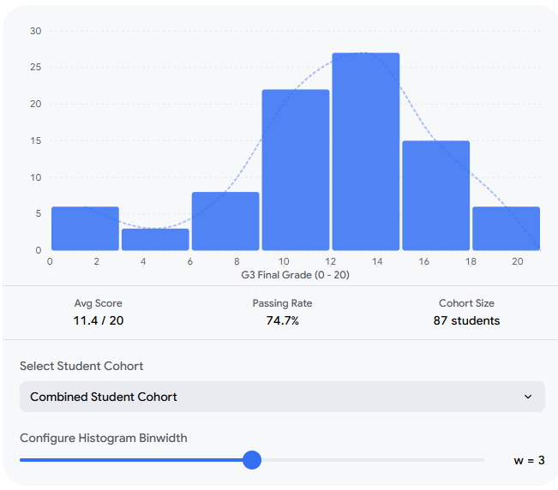

11. SCATTER PLOT OF STUDY TIME AND FINAL GRADE
A scatter plot is used to examine the relationship between study time and final academic performance.
ggplot(student_data, aes(x = studytime, y = G3)) +
geom_point() +
labs(
title = "Study Time and Final Grade",
x = "Study Time",
y = "Final Grade"
)
Interpretation
The scatter plot allows the relationship between weekly study time and final grade to be visually examined.
The distribution of points can indicate whether students with different levels of study time show different patterns in their final grades.
This visualization is useful for identifying possible relationships that can be investigated further during predictive modeling.
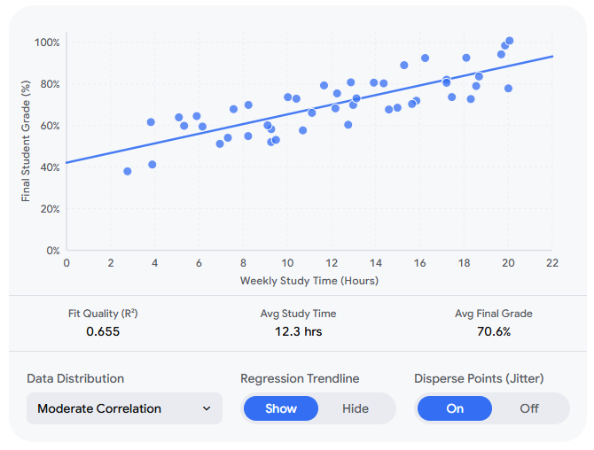

12. BOXPLOT OF FINAL GRADE BY STUDY TIME
A box plot is used to compare the distribution of final grades across different study-time categories
ggplot(student_data, aes(x = factor(studytime), y = G3)) +
geom_boxplot() +
labs(
title = "Final Grade Distribution by Study Time",
x = "Study Time Category",
y = "Final Grade"
)
Interpretation
The box plot provides information about the median, spread, and possible unusual observations within each study-time category.
Comparing the groups helps identify differences in academic performance across students with different reported levels of study time.
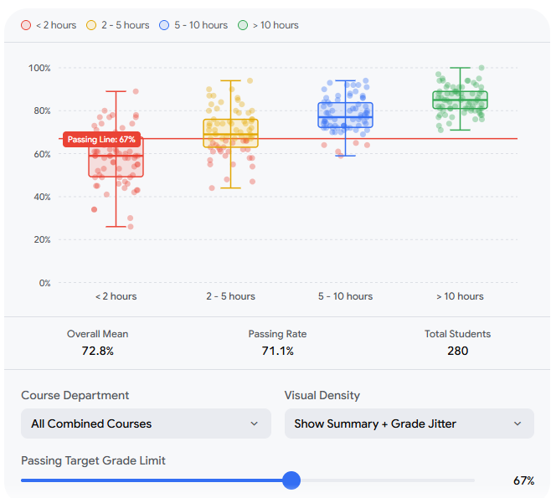

13. CORRELATION ANALYSIS
Correlation analysis can be used to examine relationships among numerical academic variables.
cor(student_data[, c("age", "studytime",
"failures", "absences",
"G1", "G2", "G3")])
The correlation results help identify numerical variables that have stronger or weaker relationships with final academic performance.
The results can be further visualized using a correlation heatmap if required.

14. KEY OBSERVATIONS
The exploratory analysis provides several areas for further investigation:
- Final grades show variation among students.
- Study time can be examined as a factor associated with academic performance.
- Previous failures provide information about students' academic history.
- Absences provide another variable that can be investigated in relation to performance.
- Previous grades G1 and G2 provide useful information about final grade G3.
- Visualization makes patterns and distributions easier to understand than examining raw data alone.
- The identified variables can be considered during the preprocessing and predictive modeling stages.
These observations are exploratory and do not by themselves establish cause-and-effect relationships.

15. IMPORTANCE OF EDA IN THE PROJECT
EDA is important because it provides an understanding of the dataset before machine learning models are developed.
Without EDA, problems such as missing values, unusual observations, incorrect data types, or unexpected distributions may remain unnoticed.
The visualizations also help identify potentially useful variables for predictive modeling. The findings from Week 2 will therefore guide the data preprocessing work in Week 3 and model development in Week 4.

16. LIMITATIONS
The analysis has some limitations:
- The dataset represents a specific student population and may not represent all students.
- Observational data cannot automatically establish causal relationships.
- Some variables are self-reported.
- Academic performance can be affected by many factors that may not be included in the dataset.
- Predictive results should therefore be interpreted within the context of the available data.

17. CONCLUSION
The Week 2 exploratory data analysis provided an initial understanding of the Student Performance dataset using R.
The dataset was imported, examined, and checked for data-quality issues. Summary statistics were used to understand important numerical variables, while histograms, scatter plots, and box plots were used to visually explore distributions and relationships.
The analysis provides a foundation for the next stage of the project. In Week 3, the dataset will undergo more detailed data wrangling and preprocessing, including handling data-quality issues, transforming variables, and preparing the data for predictive modeling.
Overall, exploratory data analysis helps convert raw student-performance data into meaningful information that can support later statistical and machine-learning analysis.

18. REFERENCES
- UCI Machine Learning Repository – Student Performance Dataset.
- R Documentation – R Programming Language.
- Wickham, H. et al. – ggplot2: Elegant Graphics for Data Analysis.
- RStudio / Posit Documentation.
- Publicly available documentation associated with the Student Performance dataset.

APPENDIX – R CODE
# Load packages
library(ggplot2)
library(dplyr)
library(tidyr)

# Import data
student_data <- read.csv("data/student-mat.csv", sep = ";")

# View data
head(student_data)

# Structure
str(student_data)

# Dimensions
dim(student_data)

# Summary
summary(student_data)

# Missing values
colSums(is.na(student_data))

# Duplicate rows
sum(duplicated(student_data))

# Histogram
ggplot(student_data, aes(x = G3)) +
geom_histogram(binwidth = 1) +
labs(
title = "Distribution of Final Student Grades",
x = "Final Grade (G3)",
y = "Number of Students"
)

# Scatter plot
ggplot(student_data, aes(x = studytime, y = G3)) +
geom_point() +
labs(
title = "Study Time and Final Grade",
x = "Study Time",
y = "Final Grade"
)

# Box plot
ggplot(student_data, aes(x = factor(studytime), y = G3)) +
geom_boxplot() +
labs(
title = "Final Grade Distribution by Study Time",
x = "Study Time Category",
y = "Final Grade"
)

# Correlation
cor(student_data[, c("age", "studytime",
"failures", "absences",
"G1", "G2", "G3")])

